

**SCHOOL OF COMPUTING AND ENGINEERING SCIENCES**

**AN IOT-BASED CONTACTLESS DOOR SYSTEM**

STUDENT NUMBER: 108650

An Informatics and Computer Science Final Project Documentation Submitted to the School of Computing and Engineering Sciences in partial fulfillment of the requirements for the award of a Degree in Bachelor of Science in Informatics and Computer Science.

**Declaration**

I declare that this project documentation has not been submitted to Strathmore University or any other University for the award of a Degree in Bachelor of Science in Informatics and Computer Science or any other Degree.

Student Admission Number:

________________________

Sign: ________________________

Date: ________________________

Supervisor’s Signature:

Sign: ________________________

Date: ________________________

# Abstract

“3… 2… 1… Happy New Year!” people chanted with pomp as they ushered in the new year, 2020, little did they know that the world as we knew it was about to change permanently in a few months to come. SARS-CoV-2, more commonly known as COVID-19 or simply coronavirus is as its name suggests, a virus, hence has no cure. This new disease caused a lot of pain to many people as the death tally rose and infection rates kept getting higher and higher. At first, nobody knew how to best handle it hence leaving the public in a state of panic. People flooded supermarkets and stocked up on tissue paper as if preparing for a global apocalypse as others chose to surrender face-to-face interactions and opted for online communication as the only way to reach them.

It is for this reason that the developed solution explored in this project was conceived. As the adage goes, prevention is better than cure. Why not stop COVID-19 at its roots during spread instead of frantically trying to clean up its repercussions, which is both expensive and very risky? That is why a contactless door solution might be a good perspective to start with in the hopes of handling the pandemic thus enabling people to go back to normalcy as soon as possible. Majority of the automated door systems currently being implemented are geared towards other specialized uses, such as security doors at receptions, dust-free doors for labs et cetera. There is a market gap for such a system implemented in arguably the busiest part of any building, the washroom facilities.

COVID-19 is spread through direct contact with respiratory droplets of an infected person that is generated through coughing, sneezing, speaking or breathing which then enter our respiratory systems. According to Aerosol and surface stability of HCoV-19 (SARS-CoV-2) compared to SARS-CoV-1 (2020) by the New England Journal of Medicine, COVID-19 is “highly stable on plastic and stainless steel”, lasting approximately 6.8 hours on the former and 5.6 hours on the latter. It was therefore recommended to reduce naked contact with surfaces, especially in public places as they could be contaminated, which the developed solution has addressed.

# Chapter One: Introduction

## Background

The coronavirus disease took the world by storm after reports came in from Wuhan, China. According to Wang C et al. (2020), “Chinese scientists had isolated a novel coronavirus (CoV) from patients in Wuhan.” This would later change the way many things work in modern society as the world tried to navigate its way around it.

Major symptoms of this disease included loss of sense of smell and taste, fever, fatigue, and a dry cough. The infected tally grew by the minute with an average 2.14% of them succumbing to the virus. The World Health Organization chief Dr Tedros Adhanom Ghebreyesus at a media briefing declared coronavirus a pandemic on 11th March 2020 stating that he was "deeply concerned both by the alarming levels of spread and severity and by the alarming levels of inaction," and he called on countries to take action now to contain the virus. The world consequently shut down most activities in fear of this novel illness without a cure. Pundits and professionals alike gave their take on what it was with new information popping up almost every hour. Of course, as with any big news came conspiracy theories. Some were arguing about whether or not it really exists with some people claiming that it was just a hoax by the government to get people scared and thus control them. Others said that it was manufactured somewhere in a lab in hopes to “control overpopulation.” This endless stream of a mixture of verified and unverified information called upon social media platforms to control the spread of “fake news.” They began adding notifications on posts relating to COVID-19 asking users to visit the official World Health Organization website for legitimate information.

After much speculation by the public, the majority of scientists and doctors came to a somewhat consensus of what it was together with how to handle it. According to Scientific Brief: SARS-CoV-2 Transmission (2020), COVID-19 is spread through direct contact with respiratory droplets of an infected person that is generated through coughing, sneezing, speaking or breathing which then enter our respiratory systems. According to Aerosol and surface stability of HCoV-19 (SARS-CoV-2) compared to SARS-CoV-1 (2020) by the New England Journal of Medicine, COVID-19 is “highly stable on plastic and stainless steel”, lasting approximately 6.8 hours on the former and 5.6 hours on the latter. It was therefore recommended to reduce naked contact with surfaces, especially in public places as they could be contaminated. Hands are the principle means we use to touch things and this may result in spread of COVID-19 and a variety of other problems like gastrointestinal infections such as salmonellosis, and respiratory infections, such as influenza and colds. We see that this advice is simple but not necessarily easy to follow M. M. Skinner et al.(2015) as we humans, “instinctively use our hands to function” since the so-called “cavepeople” days nearly 2.6 million years ago . This calls for a better system to be put in place in order to assist us achieve the recommended course of action.

## Problem statement

According to the statistics given by the World Health Organization, new cases of the COVID-19 pandemic continue to increase daily in almost all parts of the world. This is discouraging as a large number of the population desire that the numbers decline in what they’ve dubbed “flattening the curve” in order to help fast-track us to normalcy.

The curve cannot flatten without there being an accurately assessed and well implemented course of action. The research carried out by the World Health Organization about the virus and its behavior together with the proper guidelines on how it can be controlled is very commendable. The challenge, however, is on the implementation of the advice with many organizations struggling to structure their activities accordingly, especially in the sector of reducing skin contact with potentially contaminated areas.

It was observed that it is possible to avoid physical contact with everything else in public places apart from door handles, especially those in washrooms, which require us to open using our hands. The major problems discovered were that doors used in most buildings are traditional and also that the modern solutions were quite costly. Finding a way around this could massively help reduce the spread of the virus.

## General Objective/Aim

The aim of this project is to develop an IOT-based contactless door system which will help in reducing the spread of COVID-19.

### Specific Objectives

This project is guided by the following specific objectives;

1. To investigate what challenges individuals face when trying to reduce contact with foreign surfaces.
2. To research and analyze current door systems put in place in public washrooms and entry and exit points of buildings at large.
3. To design and develop an IOT-based door system that involves zero skin contact for washrooms hence reducing spread of COVID-19.

### Research Questions

The project is guided by the following research questions;

1. What are the challenges individuals face when trying to reduce contact with foreign surfaces?
2. What are the current systems used in washroom doors and other entry and exit points of buildings at large?
3. What is to be used in designing and developing the contactless door system to help in reducing the spread of COVID-19?

## Justification

As human beings continue to operate mostly on autopilot mode, we require a no-brainer strategy that is easy, effective and relatively less costly than what is currently available on the market in reducing contact with the frequently touched surfaces, one of which is mentioned are door handles. Individuals themselves might consider themselves responsible in terms of reducing their contact with these surfaces but it gets difficult when they get exposed to potentially infected surfaces. This is due to the fact that they still need to reach for door handles while using public washrooms that they share with unknown people who might potentially carry the virus, hence the need for intervention in that sector. The current door designs feel outdated and not well suited for the current circumstances as they involve physical contact. The “advanced” contactless solutions are also not satisfactory as they often have high power consumption that may be impractical to be used as a mainstream solution for even the smallest facilities. This solution needs to be developed as not only will it reduce the chance of spread of COVID-19 but also a plethora of other infections such as influenza, salmonellosis and colds.

## Scope and Limitations

### Scope of the project

The scope of the project will solely cover a user opening and closing a washroom door without using hands. The users of this door system will use a foot lever to mechanically open and close the door. They will afterwards lock and unlock it by connecting to the door wirelessly using their phone hence controlling the lock from there.

### Limitations of the project

This project will require acquiring IOT devices which will be costly. To make this system, one will need to gain more knowledge on various IT technologies in order to implement and bring the actual project to life. Another limitation is that users of these systems will still be required to touch toilet flush handles and buttons which are yet to be improved on.

# Chapter Two: Literature Review

## 2.1 Introduction

This chapter discusses the existing door systems that are responsible for access into the washroom facilities. It also discusses the challenges encountered and the gaps that are in these systems which will inspire the resultant solution I desire to implement.

## 2.2 Challenges faced by

### 2.2.1 Users

According to Gerba (2014), “one single contaminated door handle could infect up to 60% of the occupants of a building within just 4 hours” hence they may experience anxiety due to the looming threat of potentially contracting the virus that may result from sharing door handles in washrooms.

### 2.2.2 Organization

There is an increased cost of labor due to the fact that current door systems involving contact require regularly disinfecting. This also results in reduced revenue due to the cost of purchasing cleaning equipment for regular disinfection. There is also a possibility of being responsible for a COVID-19 case if it happens on their premise due to insufficient safety procedures to protect the health of people within the facilities. There is also decreased comfort and satisfaction from members of such organizations who might feel neglected in the midst of a worldwide pandemic when no action is taken to ensure their safety in this regard.

## 2.3 Existing solutions

### 2.3.1 Traditional Washroom Doors

This is our everyday door we see common in most buildings. They feature a door handle which a user utilizes to gain access into and out of a premise. It has a red and green paper that indicates whether the facility is occupied or vacant: When the door is locked, it indicates occupied while the opposite signals that it is vacant hence free for use. They have served us well thus fear but are the worst given the current COVID-19 situation.

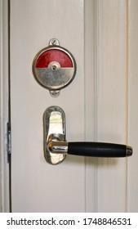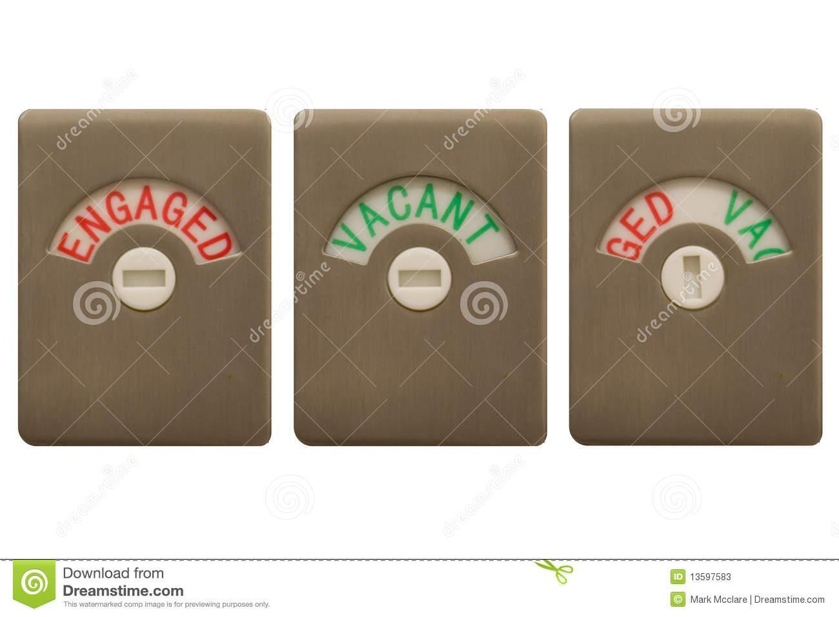

#### Figure 2.1: Traditional Toilet Door System

### 2.3.2 NABCO Hermetic Door NAX

NABCO is a company that specializes in making automatic doors. Their Hermetic Door NAX system features a metallic door that grants access to users. The user places their palm near the sensor and this causes the door to slide open after sensing the person. Their unique selling point is having “high air tightness” as the door is pushed tightly to the wall and drops to the floor which helps keep the interior clean and free from aerial debris such as dust. It is mostly marketed to hospitals with operating rooms as the equipment there is sensitive to impurities. The door also has a sunken handle to be used in case of an emergency or power failure.

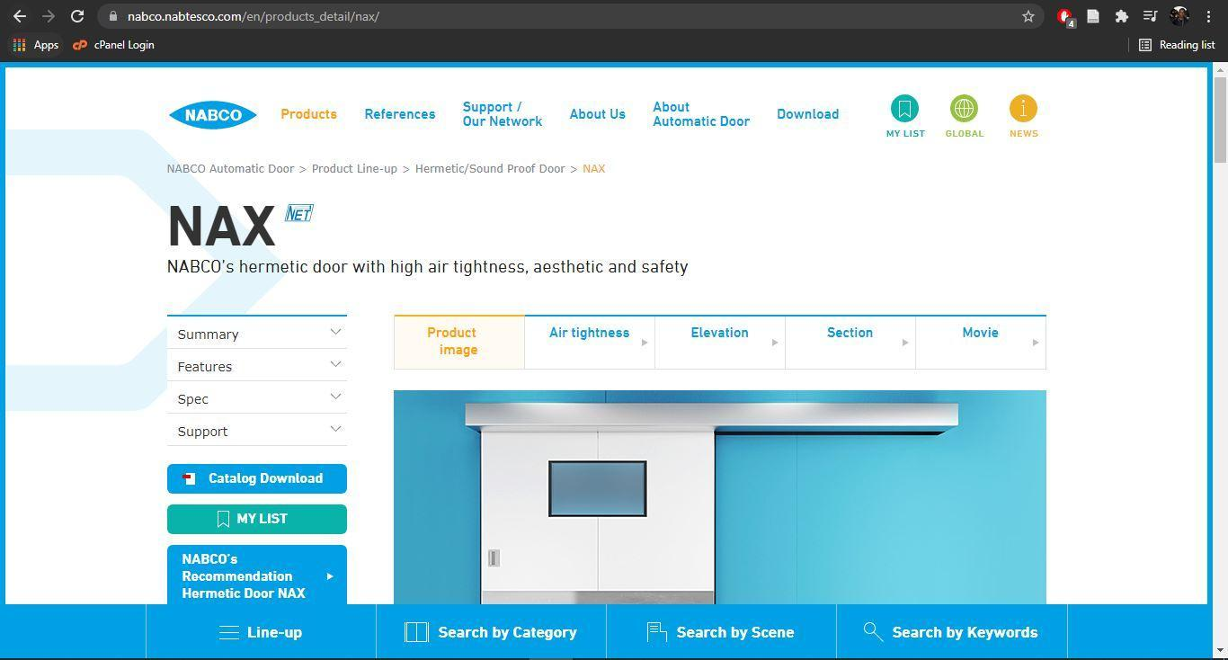

#### Figure 2.3: NABCO Hermetic Door NAX Door System

### 2.3.3 Dormakaba Argus Sensor Barriers

The design features two glass doors that open inside upon sensing a person approaching. There are two large metallic components holding the doors that also act as sensors for incoming persons. Judging by the design, this system seems to be marketed to reception and security departments of organizations as they are quite strong and durable.

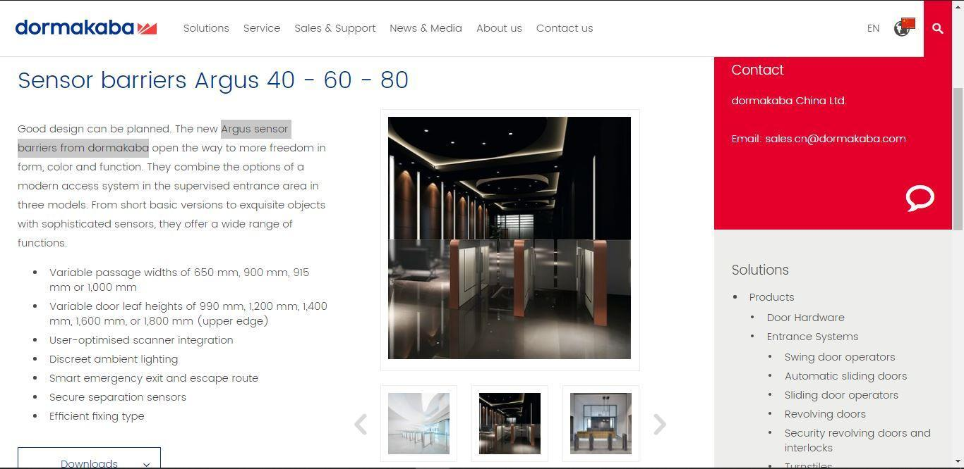

### Figure 2.4: NABCO Hermetic Door NAX

### 2.3.4 ASSA ABLOY SW-60

This system offers a variety of features and mechanisms for opening and closing doors. ASSA ABLOY SW-60 features a swing door operator controlled using a mobile phone that opens the door like any other normal door currently in use, but with an added metallic arm-like appliance at the top used to control the actual movement. One feature includes “partial open” which keeps the door open at an angle you want to leave it. Another feature is being able to close the door using a small nudge instead of waiting for their standard 5 second hold open time. Another feature they have is wave to open and wave to close as it also has motion sensors. Another feature is “push & go” which allows one to nudge it a little and it opens.

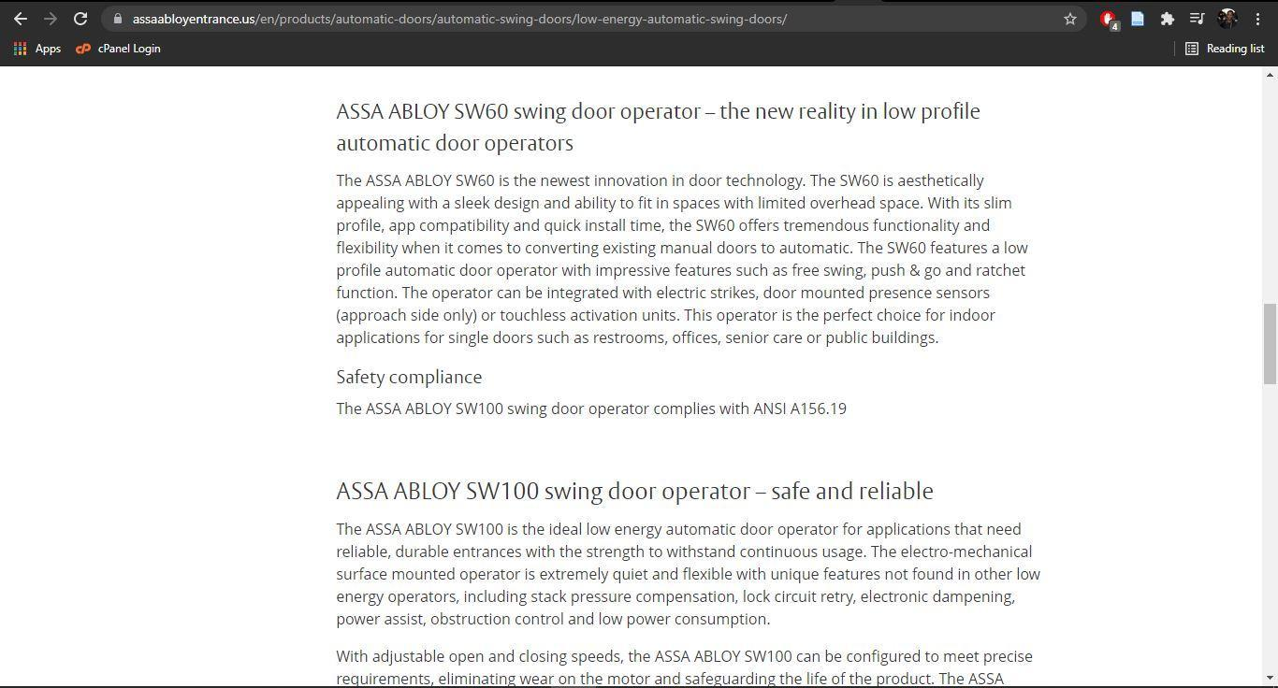

**Figure 2.5: ASSA ABLOY SW-60**

## 2.4 Gaps in the Existing solutions

The existing solutions cater only for specialized needs such as building entrance security and operation rooms and are not optimized for washrooms for example showing whether the space is vacant or occupied. Another problem with such systems is their highly power-intensive models which require a lot of energy spent on just opening and closing doors hence discouraging organizations from making such investments. Another foreseeable issue is difficulty in installing such systems in our current buildings, which might require us to remove the doors and replace them with new ones, for instance those that slide into the wall, instead of simply adding to the already existing ones hence being too expensive.

## 2.5 Conceptual Framework

This is a visual representation that explains the relationship and interaction between the system components. There is an LED light connected to the door system. A person uses the outer foot lever to mechanically slide the door open. Once inside, they use the inner foot lever to close the door shut. Afterwards, they connect to the door system via Bluetooth and lock it. This changes the LED light to signal that the facility is occupied which allows them to run their business without any interference from any others waiting to use it that may be unaware of an occupant. After they are done using the facility, the person unlocks the door using Bluetooth, slides the door open using the inner foot ever and finally closes it using the outer foot lever. The person is free to disconnect from Bluetooth and leave after successful use.

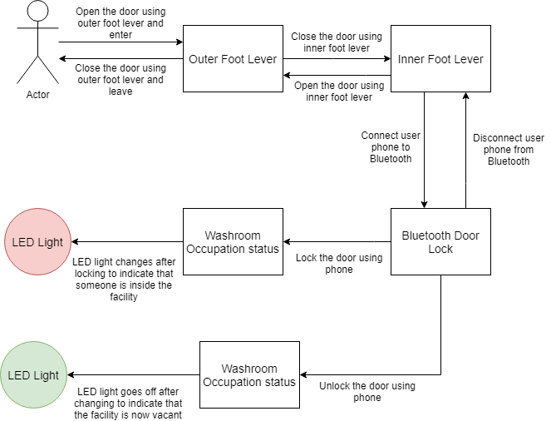

**Figure 2.6: Conceptual Diagram**

# Chapter Three: Development Methodology

## 3.1 Introduction

This section represents the software development methodology and various aspects of system analysis, design and implementation. Furthermore, this chapter highlights tools and techniques used in IOT development, the expected system resources needed to develop this system.

## 3.2 Software Development Methodology

Software Development Methodology is a framework that is used to structure, plan and control the process of developing an information system. This includes the pre-definition of specific deliverables that are created and completed by a project team to develop and maintain an application. In this project, we will use agile development methodology.

### 3.2.1 Requirement Analysis

In this phase, a document is created to list the initial requirements needed to start the project. It will generally give an overview of the end result of what the project will be able to achieve, the features that it will have and features that will not be supported by the system

### 3.2.2 Design

The system will have two ways to approach the design in developing the software. With the software design, we will need to tackle the requirements stated in the previous stage to achieve the best results. A rough mock-up of the UI will be needed since the product is consumer-grade, the user experience and interface are really important.

### 3.2.4 Development

At this stage, the execution of the plan and system design will take place. It involves writing code and converting the design into actual software. A prototype will be built to emulate a smart parking system.

### 3.2.5 Testing

The developed system prototype will be tested to detect errors that happen at an early stage and correct them till it is presented to the user. At this stage is where we check if the user requirements have been set.

### 3.2.6 Implementation and Deployment

The complete system will be deployed for the demo or actual use of the system. In this stage, further iterations assist in updating the software, having new features and fixing bugs that come up.

## 3.3 Software Requirements Analysis

Software requirement analysis is the process where user expectations for a new software are created and modified. It encompasses tasks that are to determine the needs or certain conditions to meet the project taking into account the conflicting requirements of various stakeholders, analyzing and managing the software requirements.

### 3.3.1 Functional Requirements

These are the operations and activities that the system must be able to perform. The system should be able to lock and unlock the door via Bluetooth. The system should be able to accurately indicate the occupation status of that particular washroom.

### 3.3.2 Non-Functional Requirements

It defines the qualities of a system. The system should be entirely contactless as far as skin to door contact is concerned. The system should be cheap to install and easy to use.

### 3.3.3 System Narrative

The IOT-based Contactless System will ensure that people can access public washrooms and use the facilities without having to touch the door using their hands at any given point of time. This is due to the fact that the door is locked and unlocked via Bluetooth and the door is opened and closed using foot levers. Hopefully, this manages to be a cheaper yet effective solution compared to all others in the market thus controlling the spread of COVID-19.

## 3.4 System Design

System design is the process of defining the architecture, modules, interfaces and data for a system to satisfy the specified requirements.

### 3.4.1 Use Case Diagram

A use case diagram is a simple diagrammatic representation of the user’s interactions with the system’s elements . It may include actors , use cases and system boundaries. The use case diagrams give a brief representation of what the various actors will be doing as they interact with the system from time to time.

### 3.4.2 Entity Relationship Diagram

An entity relationship diagram is a diagram that shows the representation of the data used and created by a business system. It shows data and the relationship between the people, places and things. In other words it is a picture or diagram showing the information created , stored and used by a business system. The entity relationship diagram describes the various activities done in relation to other activities in the system.

### 3.4.3 Class Diagram

This is a type of static structure diagram that describes the structure of a system by showing the system's classes, their attributes, operations, and the relationships among objects.

## 3.5 System Development Tools and Techniques

### 3.5.1 Tool 1: Arduino UNO

It is a physical circuit board that will be able to control the Servo motor and host both the Bluetooth module and LED light.

### 3.5.2 Tool 2: Arduino IDE

Arduino IDE will provide the programming environment that will be used to write the code that is going to be used by the Arduino microcontroller.

### 3.5.3 Tool 3: Android Studio

Android Studio will be the IDE used to develop the Bluetooth mobile application. Here is where construction of the locking and unlocking mechanism for the application will take place.

### 3.5.4 Tool 4: Barrel Door Lock

This is the lock I will implement to be used on the door.

### 3.5.5 Tool 5: Servo Motor

This will be used to control the barrel door lock hence enabling the locking and unlocking mechanism.

### 3.5.6 Tool 6: Bluetooth Module

This is what will allow our phones to connect to the door system hence allowing us to control it.

### 3.5.7 Tool 7: Resistors

These will be for the Bluetooth module’s voltage divider circuit.

### 3.5.8 Tool 8: Wires

These will help connect various tools to the Arduino UNO.

### 3.5.9 Tool 9: Swinging Door

This will simulate a real world scenario of a door. It will be designed to function like a normal door but without the usual door handles.

### 3.5.10 Tool 10: Foot Levers

There will be two of these at the bottom of both the inside and outside of the door. They will aid in opening and closing of the door.

### 3.5.11 Tool 11: 5mm LED: Red

This will be used to indicate whether or not the washroom facility is vacant or occupied.

## 3.6 Deliverables

### 3.6.1 Contactless Door

This will be a physical representation of a real world scenario of the door in action. It will come complete with the lock, foot levers and LED light.

### 3.6.2 Bluetooth Application

This will be a software application running on a smartphone that will allow the user to connect their phone to the contactless door system hence controlling it. The application will be called Mlango Wangu.

# Chapter Four: System Analysis and Design

## 4.1 Introduction

This chapter discusses the analysis and design of the system. It also discusses the functional and non-functional requirements of the system. It also includes the design diagrams of the system and an explanation of the system workings.

## 4.2 System Requirement Analysis

System Requirements Analysis assists the professional systems engineer in investigating a system, identifying problems and recommending improvements of the system. They are able to set up a proper and effective analysis of the resources, schedules and parts needed to successfully undertake and complete any project. It improves the system as a whole.

### 4.2.1 Functional Requirements

Functional requirements are the main purposes of a system or its component, where a function is described as a specification of the manner of interaction between the inputs and outputs (Fulton & Vandermolen, 2014). It is necessary for them to be complete and consistent.

The functional requirements for this project include the following:

1. The user should be able to connect to the door system using their phone through Bluetooth.
2. The system should receive and understand user commands issued from the phone.
3. The system should be able to respond to the user’s commands appropriately, in this case blinking LED light, locking and unlocking the door.

### 4.2.2 Non-Functional Requirements

Non-Functional requiremenets impose constraints on the design or implementation such as performance requirements, security, or reliability (Fulton & Vandermolen, 2014).

The project will embody some of the following Non-Functional requirements:

1. The program should have minimum connection errors while linking the phone to the system’s Bluetooth module.
2. The program should have a user interface that is easy to understand and utilize. This will be accomplished through having minimum text but instead incorporating only the necessary icons.
3. The program should be fast and efficient in carrying out its functions.

### 4.2.3 System Narrative

The system has been developed for use by persons utilizing public washroom facilities in the hope of reducing spread of COVID-19. A common way people spread the virus is through naked interaction with infected surfaces such as door handles, which the system tries to reduce.

First, the system is installed in the washroom facilities as follows: The arduino components are stuck to the door by means of drilling or adhesive cases. The motor responsible for opening and closing motion is then hooked to the door’s existing door lock, depending on the type of lock it is. A power supply is connected to the system components through its power port, with the rating being at least 5 Volts. The system’s casing contains the name of the Bluetooth device to connect to.

Once the system is installed, it is ready for use. Upon visit, a new user downloads the Arduino Bluetooth controller application called “Mlango Wangu” from Google Playstore. They then turn Bluetooth on by tapping the Bluetooth icon located in their phone’s settings. The user opens the downloaded Mlango Wangu applicatoin. Inside the application, they connect to the Bluetooth Module HC-06 by tapping the brown Bluetooth icon at the top center of the application. If the connection is successful, the application changes its status from “Disconnected” to “Connected.”

Once this setup is complete, they can use the foot lever to enter the facility by swinging the door open. Once inside and after closing the door, they tap on the “Lock” icon which sends text “0” to the Arduino system hence the door is locked. A red LED light flashes outside, indicating that the washroom is currently occupied. After utilizing the facility, they simply tap on the “Unlock” icon which sends text “1” to the Arduino system hence locking the door and turning red LED light off, indicating that the washroom is free to use. They can then use the foot lever to swing open the door and disconnect from the Bluetooth controller application by tapping on the Bluetooth icon. The next time they come to use it, all they need to do is simply click on the Bluetooth icon on their phones and hit the Bluetooth icon on the application and they are set.

## 4.3 System Design

System design is the process of designing the elements of a system such as the architecture, modules and components, the different interfaces of those components and the data that goes through that system (Odhiambo, System Design in Software Development, 2018).

### 4.3.1 Use Case Diagram

A Use Case Diagram is a graphical illustration of the manner in which elements of the system interact with one another. It may include actors, use cases and system boundaries.

The Use Case Diagram for proposed system is as follows:

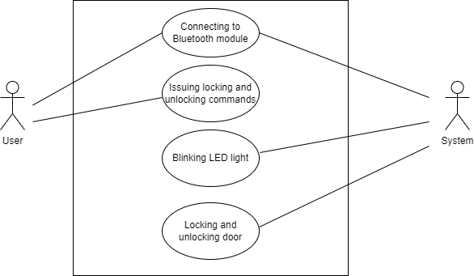

**Figure 4.1: Use Case Diagram**

## 

### 4.3.2 Sequence Diagram

A Sequence Diagram shows object interactions arranged in time sequence. It depicts the objects and classes involved in the scenario and the sequence of messages exchanged between the objects needed to carry out the functionality of the scenario.

The Sequence Diagram for proposed system is as follows:

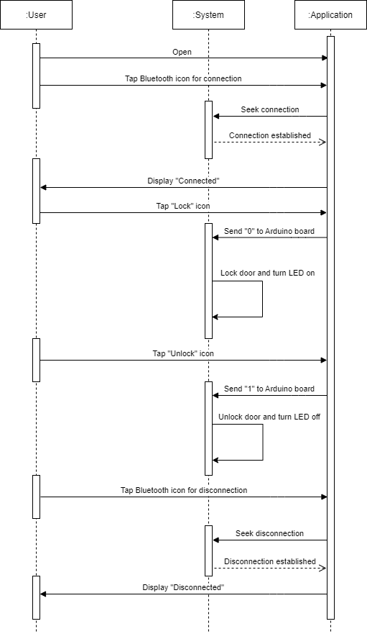

**Figure 4.2: Sequence diagram**

# Chapter Five: System Implementation and Testing

## 5.1 Introduction

This chapter explains the step-by-step process used in implementing and evaluating the system as done by Mlango Wangu.

## 5.2 The Implementation Environment

This section explores ideal environments necessary for full utilization of the implemented system capabilities.

### 5.2.1 Hardware Specifications

The following are the minimum requirements necessary to implement the system:

1. Android Smartphone device
2. More than 11 Megabytes of phone storage
3. More than 1 Megabyte of memory
4. A lockable door

### 5.2.2 Software Specifications

The following are the minimum requirements necessary to implement the system:

1. Android version 5.0 and above (recommended version is 10 for smooth interface)

## 5.3 System Implementation User Interfaces

This section outlines the different pages that the user will interact with together with their functions.

### 5.3.1 Mlango Wangu Application Download

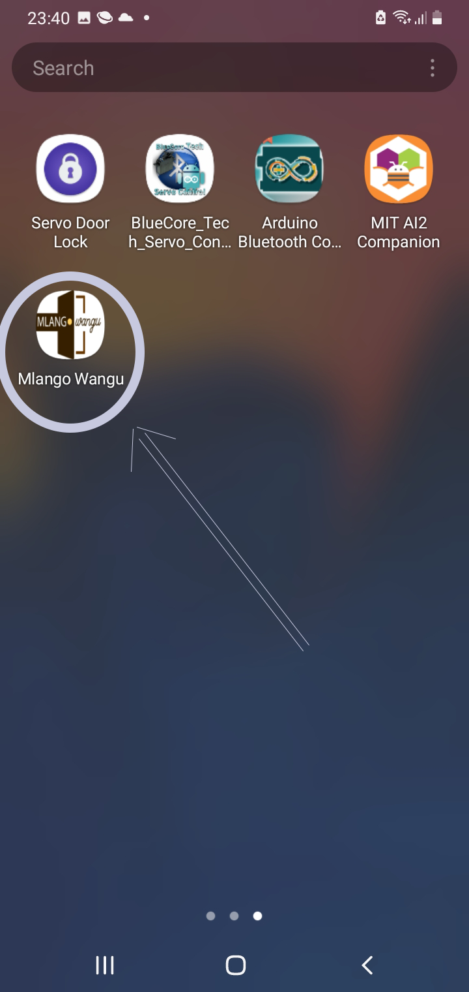

**Figure 5.1: Mwango Application Icon**

The figure shown above represents the application which a user will have to download first before being able to use the system.

### 5.3.2 Bluetooth Module Connection

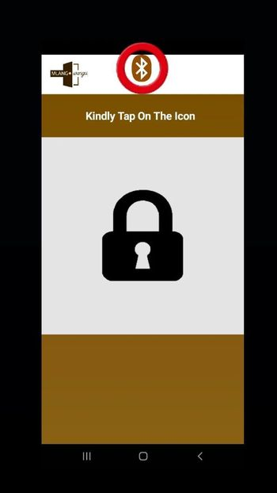

**Figure 5.2: Bluetooth Icon**

The figure above shows a button the user needs to press in order to establish a connection with the system’s Bluetooth Module.

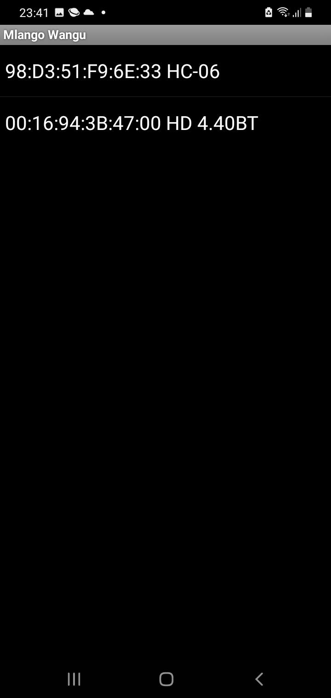

**Figure 5.3: Bluetooth Device List**

The figure above shows all available devices one can connect to within a radius of 10 meters. The user will select the Bluetooth device name for the Bluetooth Module HC-06, in this case it is 98:D3:51:F9:6E:33 HC-06.

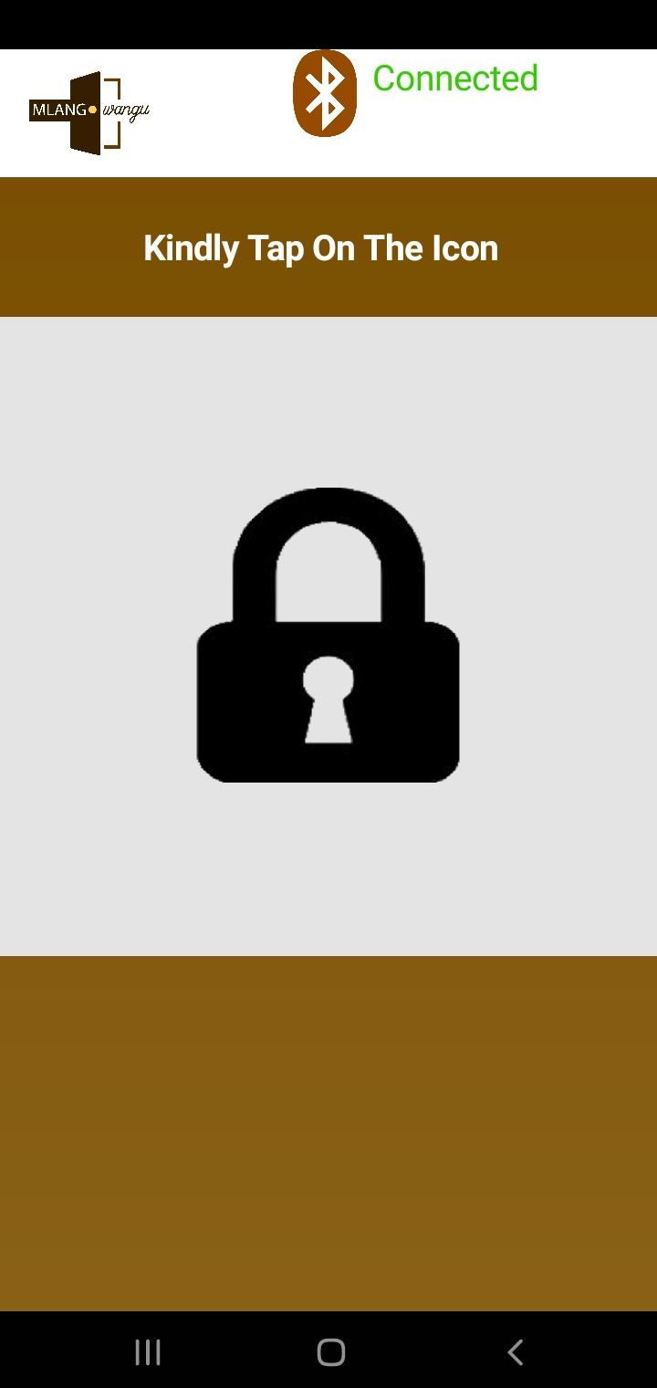

**Figure 5.4: Positive Connectivity Status**

The figure above shows how the application confirms that the user has successfully made a connection to the system. There is a green text displaying “Connected.”

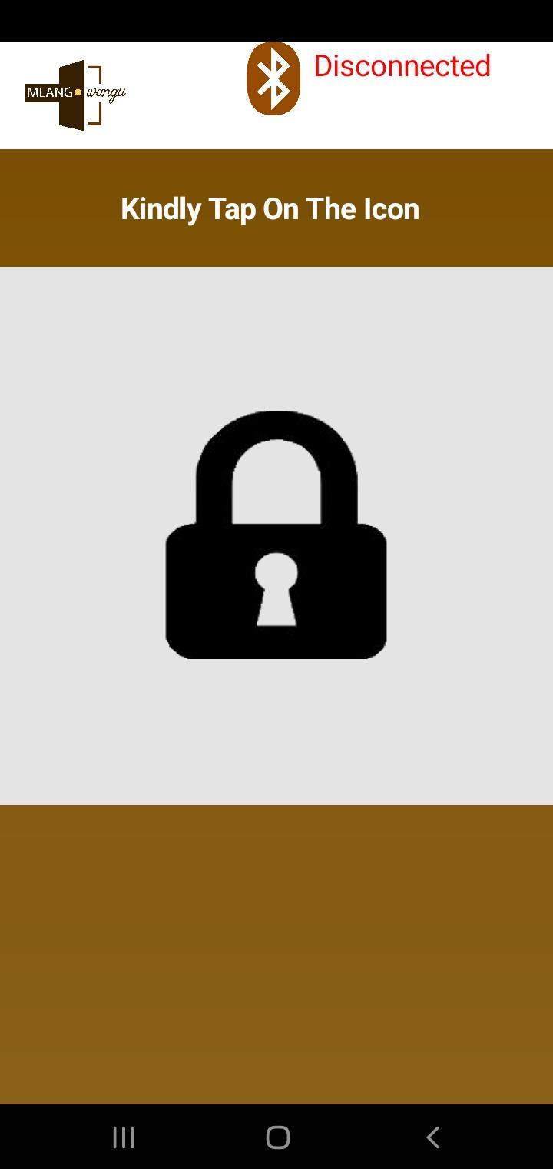

**Figure 5.5: Negative Connectivity Status**

The figure above shows how the application confirms unsuccessful connection to the system by the user. There is a red text displaying “Disconnected,”

### 5.3.3 Unlocking The Door

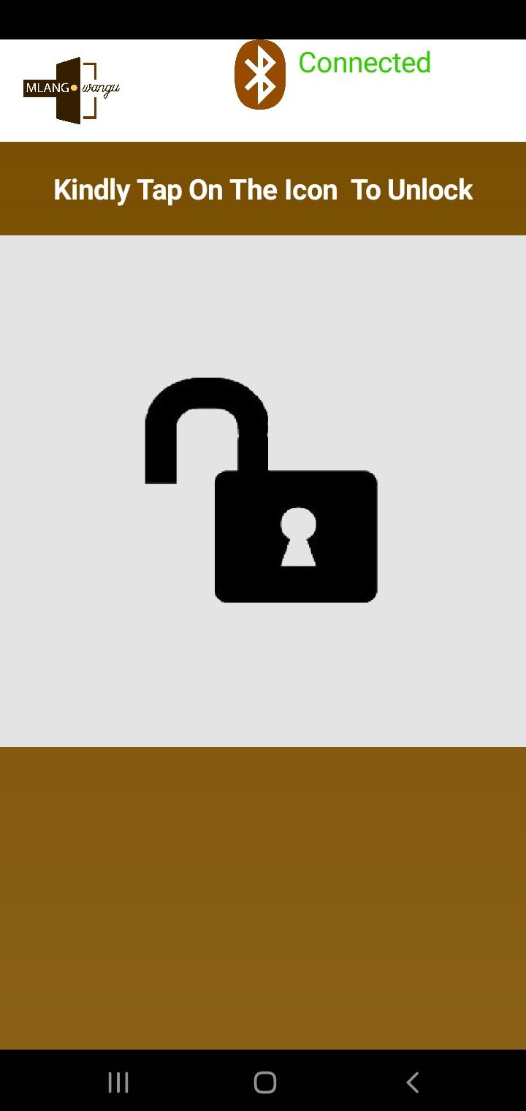

**Figure 5.6: Unlocking The Door**

The figure above shows the “padlock” icon open, indicating that the user should tap on it in order to unlock the door.

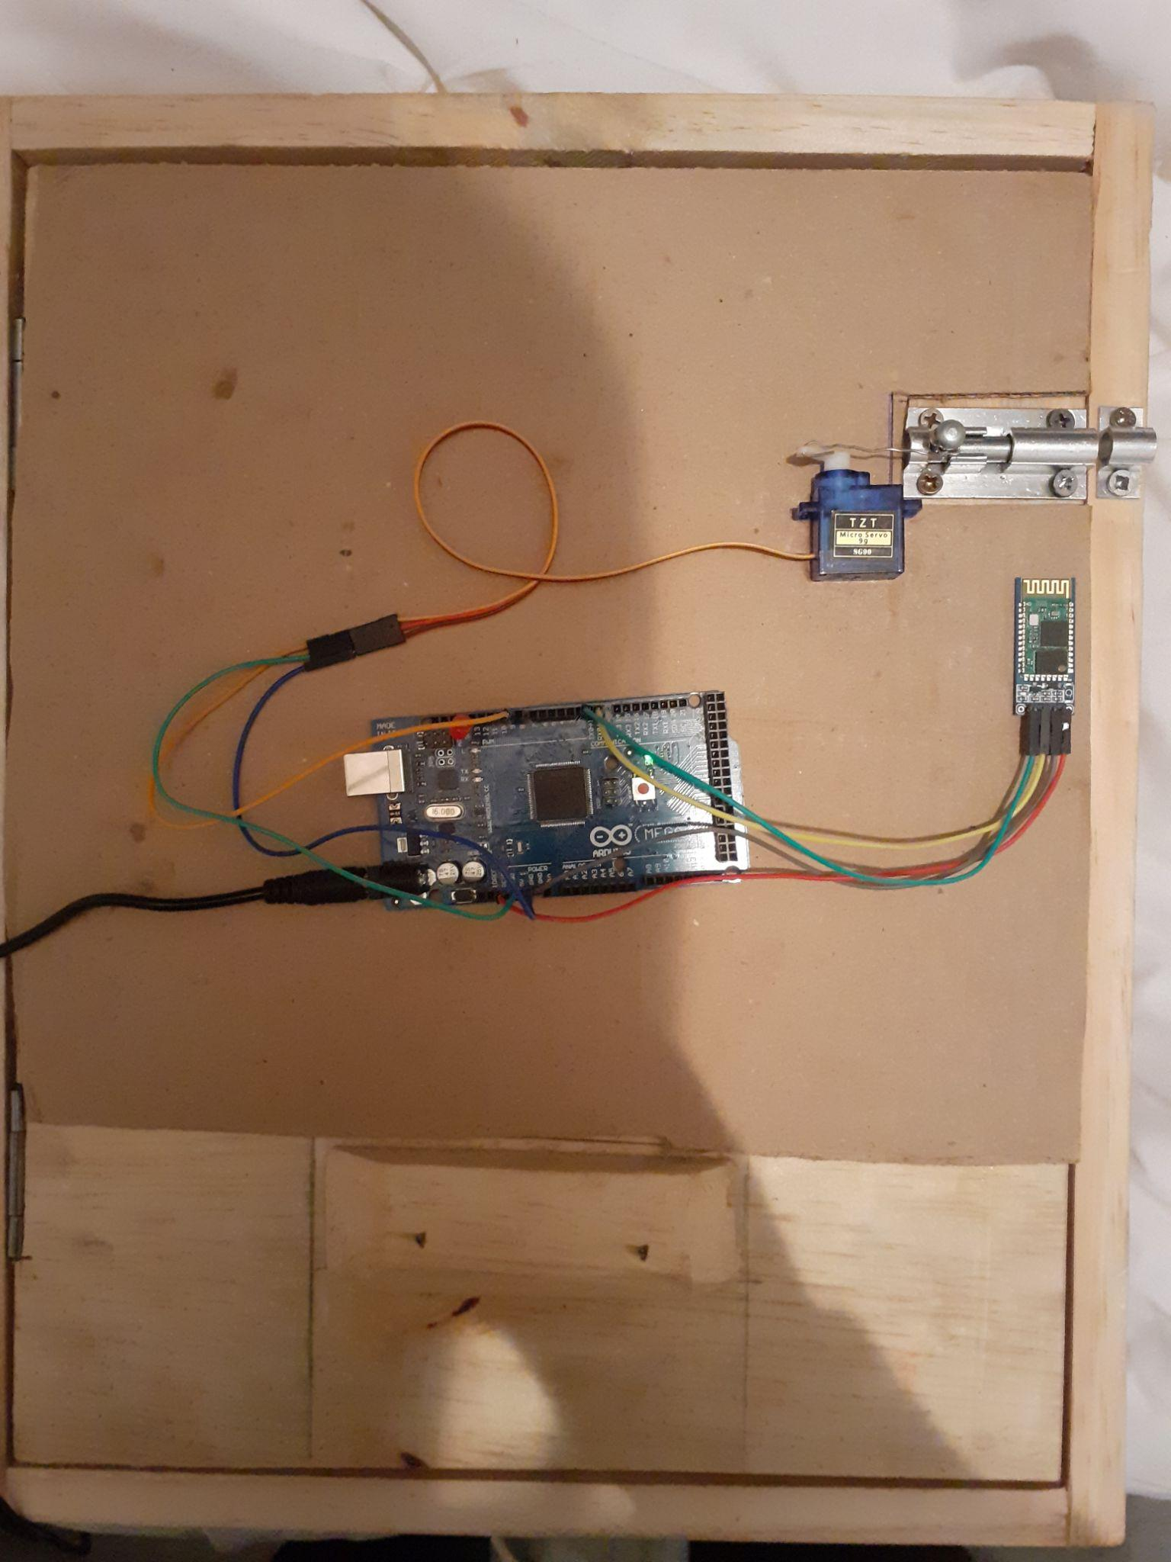

**Figure 5.7: Door In Unlocked State**

The figure above shows how the door appears from the outside of the toilet when in an “Unlocked” state. The LED Lights are not on in order to signal that the facility is vacant.

### 5.3.4 Locking The Door

In a locked state, the application mirrors Figure 5.5. You are required to tap on the closed “padlock” in order to unlock the door.

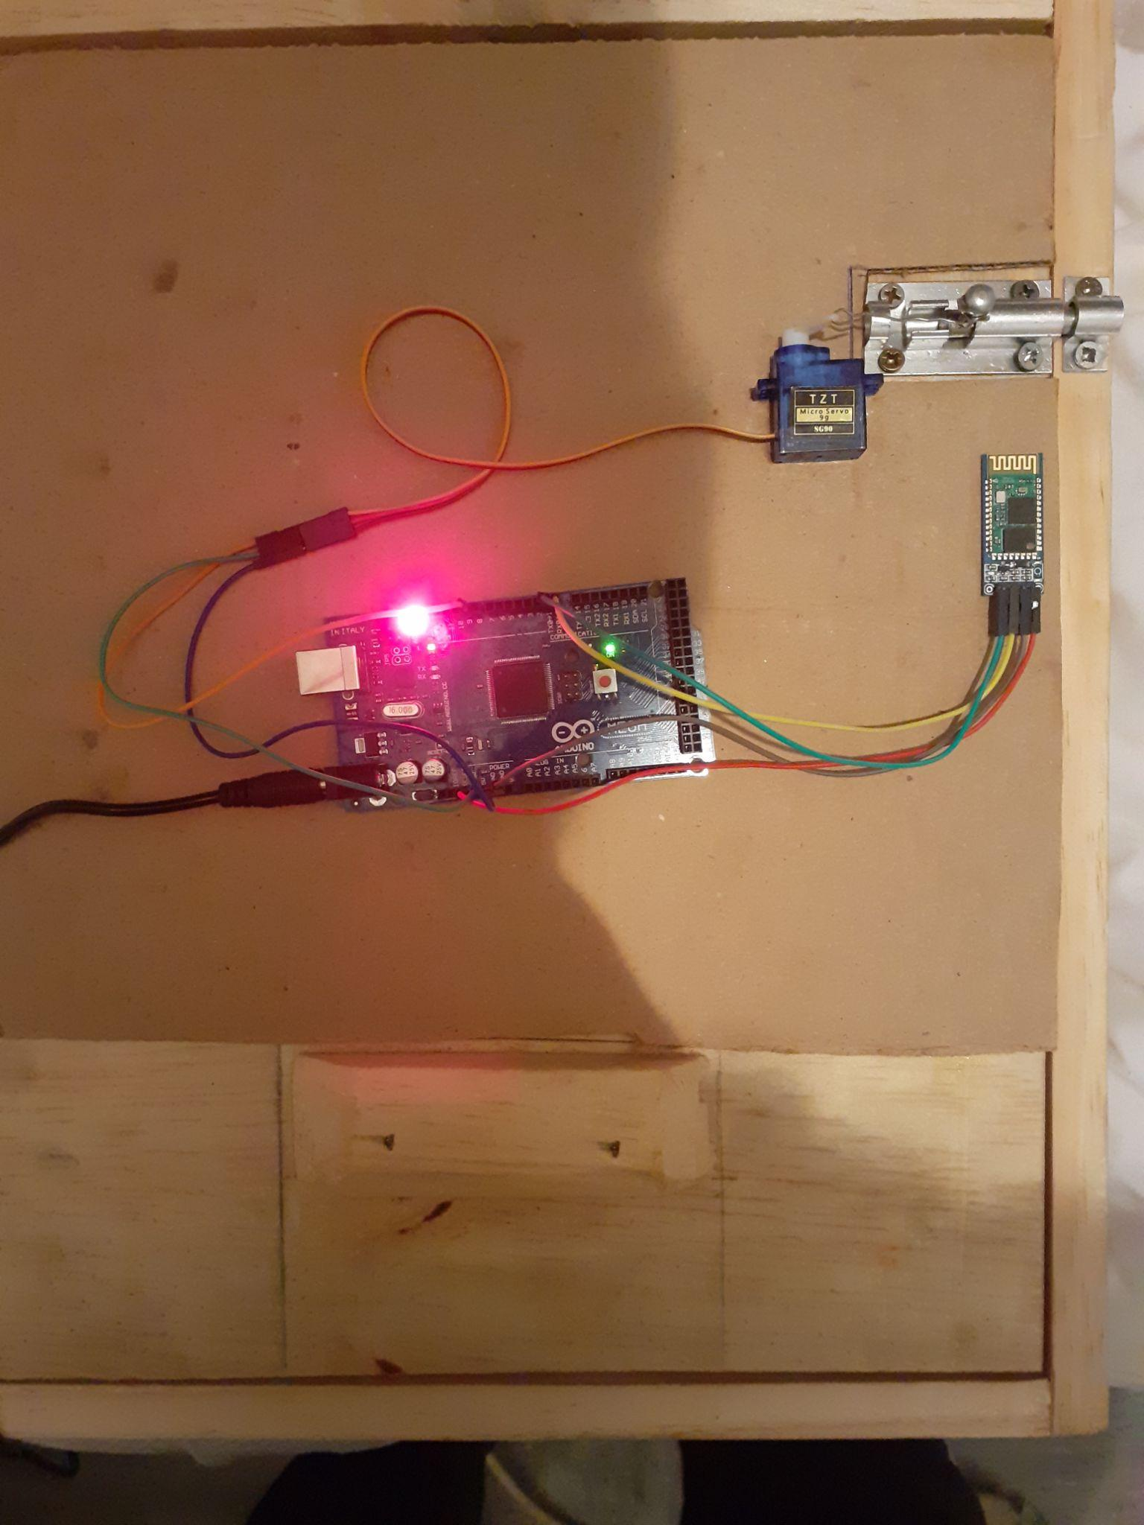

**Figure 5.8: Door In Locked State**

The figure above shows how the door appears from the outside of the toilet when in a “locked” state. There is a red LED light indicating that someone is inside the facility.

## 5.4 System Testing

The entire system was tested before implementing any of the features. Tests were carried out on both the Mlango Wangu Android application and the physical system. The tests were as follows: Android application was tested severally through interacting with the APK on mobile phone and seeing how fast it responds to button clicks as well as transmitting signals to and from the system. The motor was put to the test by trying out various locks and determining whether or not it had the strength to pull them. The Bluetooth Module was tested by investigating how far a user can be but still remain connected to it. The LED light was tested once during implementation to determine if it was working properly or was faulty before installation.

### 5.4.1 Bluetooth Module Capabilities

| **Test Case** | **Description** | **Test Data** | **Expected Outcome** | **Actual Results** | **Test Verdict** |
| --- | --- | --- | --- | --- | --- |
| TC001 | Determine the maximum connectivity distance | Distance in meters from the Bluetooth module | 10 meters | 9.23 meters | Fail |
| TC002 | Determine the maximum number of devices at a time | Number of devices issuing commands to door system | 5 | 5 | Pass |

### 5.4.2 Servo Motor Capabilities

| **Test Case** | **Description** | **Test Data** | **Expected Outcome** | **Actual Results** | **Test Verdict** |
| --- | --- | --- | --- | --- | --- |
| TC003 | Determine whether servo motor is strong enough to move door lock | Movement of door lock connected to servo motor SG90 | Successful outcome | Successful outcome | Pass |

### 5.4.3 Mlango Wangu Application Efficiency

| **Test Case** | **Description** | **Test Data** | **Expected Outcome** | **Actual Results** | **Test Verdict** |
| --- | --- | --- | --- | --- | --- |
| TC004 | Determine the amount of time it will take to open the application | Time taken by phone to open app (in seconds) | Less than one second | 1.30 seconds on average | Fail |
| TC005 | Connectivity time for phone to link system | Time taken by phone to connect to Bluetooth Module HC-06 (in seconds) | Less than one second | 2 seconds | Fail |
| TC006 | Amount of errors from interacting with the buttons on the application | Number of errors/Number of attempts * 100 | 0 | 0 | Pass |

# Chapter Six: Conclusions, Recommendations and Future Works

## 6.1 Conclusions

The Contactless Door System could be a vital tool in fighting the spread of COVID-19. The ability to use a frequently visited facility as a washroom without having the fear of contracting the virus is one cause worth pursuing. The launch of this project into the mainstream will attract other side benefits such as controlling gastrointestinal infections such as salmonellosis, and respiratory infections, such as influenza and colds. If this system gets up and running as soon as possible, I am almost certain that we will start seeing positive results as far as a drop in daily COVID-19 positivity rates is concerned. This, alongside other safety measures recommended by the World Health Organization and governments alike, will help the world population stride towards normalcy in the near future.

## 6.2 Recommendations

This application is best suited for public institutions and other large private organizations such as universities where people coming from different places frequent a lot. It may not be best suited for private use for example homes as the members sharing a washroom may find themselves sharing other facilities which are difficult to avoid contact for example seats. It is especially recommended where installation of a quick solution to handle volumes of people entering and leaving a facility before other more comprehensively automated doors can be installed such as pit latrines. Good ergonomics is encouraged if implementing this solution to many facilities at a time because improper cable management could result in lack of aesthetic appeal as well as danger in case someone trips over loose wires.

## 6.3 Future Works

In the future, we hope to make this solution available to all other operating systems and not only limited to Android users as is the case. We have the hope of using an environmentally friendlier power supply than AC such as solar which will not only make the system more portable but also result in better care of our planet. We also hope to incorporate people who may have gadgets without Bluetooth features for example through motion sensors. We have plans to remove the door hinge and use motors to open and close the door, thus making it a completely automatic door.

With an increased rate of virus mutations and the looming fatal risk of vulnerable members of society such as the elderly, we need to act with urgency, and we believe that this is the best course of action to take today and be grateful for tomorrow.

# References

M. M. Skinner, N. B. Stephens, Z. J. Tsegai, A. C. Foote, N. H. Nguyen, T. Gross, D. H. Pahr, J.-J. Hublin, T. L. Kivell. *Human-like hand use in Australopithecus africanus*. Science, 2015; 347 (6220): 395 DOI: 10.1126/science.1261735

Wang C, Horby PW, Hayden FG, Gao GF (February 2020). *"A novel coronavirus outbreak of global health concern"*. Lancet. 395 (10223): 470–473.

*"Scientific Brief: SARS-CoV-2 and Potential Airborne Transmission".* COVID-19 Published Science and Research. U.S. Centers for Disease Control and Prevention (CDC). 11 February 2020. Retrieved 30 October 2020.

*Aerosol and surface stability of HCoV-19 (SARS-CoV-2) compared to SARS-CoV-1*. van Doremalen N, Bushmaker T, Morris DH, Holbrook MG, Gamble A, Williamson BN, Tamin A, Harcourt JL, Thornburg NJ, Gerber SI, Lloyd-Smith JO, de Wit E, Munster VJ. N Engl J Med. 2020 Mar 17. doi: 10.1056/NEJMc2004973. [Epub ahead of print]. PMID: 32182409.

American Society for Microbiology. *"How quickly viruses can contaminate buildings -- from just a single doorknob."* ScienceDaily. ScienceDaily, 8 September 2014. <www.sciencedaily.com/releases/2014/09/140908093640.htm>.

*Aerosol and surface stability of HCoV-19 (SARS-CoV-2) compared to SARS-CoV-1* (2020) by the New England Journal of Medicine

*NABCO’s hermetic door with high air tightness, aesthetic and safety* (2020). NABCO. Retrieved from https://nabco.nabtesco.com/en/products_detail/nax/ on 14th July 2020.

*Sensor barriers Argus 40 - 60 - 80* (2019). Dormakaba. Retrieved from https://www.dormakaba.com/ch-en/products-solutions/products/entrance-systems/speed-gates/sensor-barriers-argus-40-60-80-783196 on 14th July 2020.

*Low energy swing door operator* (September 2015). ASSA ABLOY. Retrieved from https://www.assaabloyentrance.us/en/products/automatic-doors/automatic-swing-doors/low-energy-automatic-swing-doors/ on 14th July 2020.

Fulton R, Vandermolen R (2017). *"Chapter 4: Requirements - Writing Requirements"*. Airborne Electronic Hardware Design Assurance: A Practitioner's Guide to RTCA/DO-254. CRC Press. pp. 89–93. ISBN 9781351831420. Retrieved 15 June 2018.

Odhiambo, D. (2018). *System Design in Software Development*. Nairobi.

# APPENDIX

Appendix A1: Time Schedule

**Figure A1: Gantt Chart**

Figure A,1 shows a Gantt Chart that portrays the timeline in which all activities related to the development of the project took place from conception of the idea up to the launch of the system.